Name:_________________________

**Display Your Name - MakeCode**

**What you need:**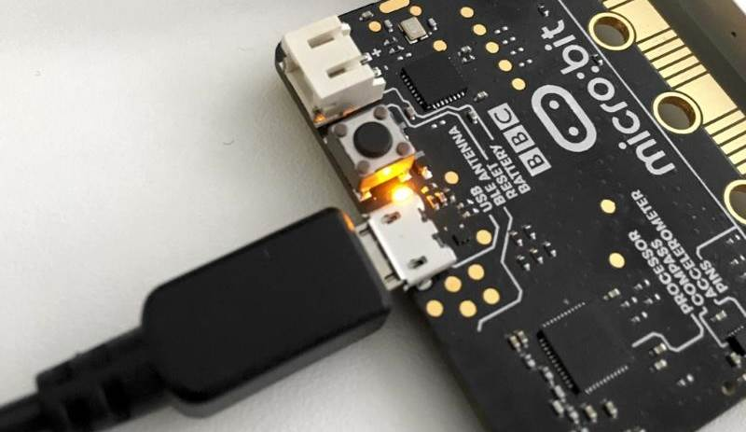

1. A computer with a USB port
2. V2.0 micro:bit
3. USB cable

**Setup:**

1. Plug in your micro:bit with the USB cable. The small USB mircoB end goes to the micro:bit and the regular USB end goes to the computer.
2. In a browser, go to <https://makecode.microbit.org/>. This is where you will program your micro:bit.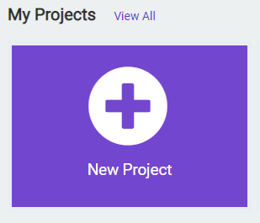
3. Click on ‘New Project’
4. You can name your project whatever you want, but you should name it based on the title of the lab. In this case, ‘Display Your Name’

**Instructions:**

1. To start, we will work in the **forever** code block. This block will continuously execute the code that we put inside this block. To display your name, click on **Basic** tab on the left hand side of the screen: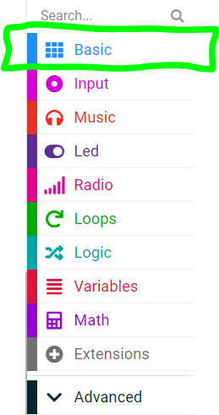
2. We want to use the **show string** code block from the menu. Click and drag it to the **forever** code block: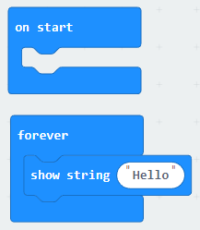
3. Click where it says “Hello!” and replace it with your name.
4. Click the **Download** button on the bottom on the bottom left hand side of the screen. This will upload your program to the micro:bit. You should be able to see your name scroll across the micro:bit screen!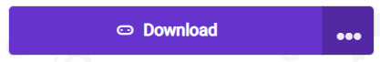

**You Try It!**

Experiment with the **show string** code block. Can you add more words to it?